Chapter 4 Apply Section

1.

10,100 into Binary, Octal, and Hex

Binary:

10,100 % 2 = 0
5050 % 2 = 0
2525 % 2 = 1
1262 % 2 = 0
631 % 2 = 1
315 % 2 = 1
157 % 2 = 1
78 % 2 = 0
39 % 2 = 1
19 % 2 = 1
9 % 2 = 1
4 % 2 = 0
2 % 2 = 0
1 % 2 = 1

10011101110100

Octal:

010 011 101 110 100
2 3 5 6 4

23564

Hex

0010 0111 0111 0100
2 7 7 4

2774

1,111 into Binary, Octal, and Hex

1111 % 2 = 1
555 % 2 = 1
277 % 2 = 1
138 % 2 = 0
69 % 2 = 1
34 % 2 = 0
17 % 2 = 1
8 % 2 = 0
4 % 2 = 0
2 % 2 = 0
1 % 2 = 1

10001010111

Octal:

010 001 010 111
2 1 2 7

Hex:

2127

0100 0101 0111
4 5 7

457

11.375 into Binary, Octal, and Hex

Binary:

11 % 2 = 1
5 % 2 = 1
2 % 2 = 0
1 % 2 = 1

11 = 1011

.375 * 2 = 0
.75 * 2 = 1
.5 * 2 = 1

.375 = .011

11.375 = 1011.011

Octal:

001 011 . 011
1 3 3

13.3 Base 8

Hex

1011 . 0110

B 6

B.6 Base 16

- Write an algorithm in pseudocode that describes how you wake up in the morning and get to work, school, etc... Include weekends!
Alarm Goes Off
While Day of Week is weekend
Turn off alarm
Go back to bed until naturally wake up 5 hours later
If Day of Week a Weekday
While Counter < 3
Snooze alarm
Go back to bed
Increase Counter
Take Shower
Get Dressed
Eat Breakfast
Brush Teeth
Get in car and drive to work
If traffic on the freeway
Take side streets to work
If no traffic on freeway
take freeway
Arrive at Work
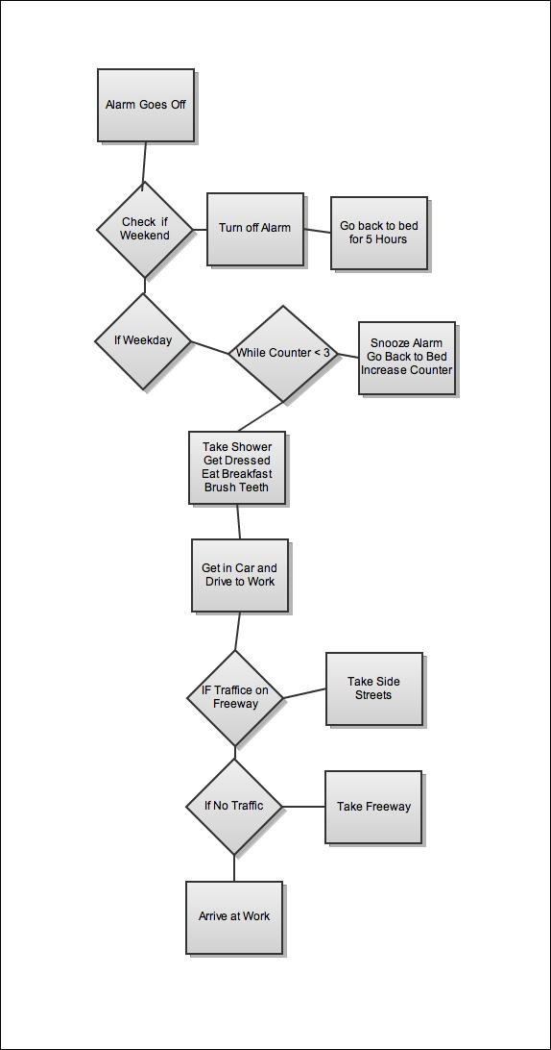
- Repeat 2) but flowchart the process.

4) If you were going to buy a car, what would be the steps in the process? Pseudocode the steps and flowchart the process.
Determine My Price Range

Research Car I’m Looking For

Determine what car is worth

Decide where to buy car

Go to car lot

While I haven’t found a car

Find a different car

Test Drive Car

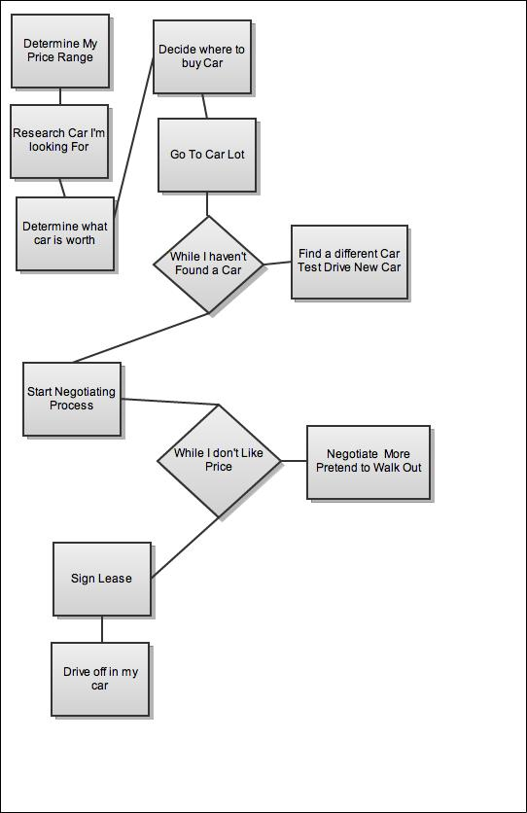
Start negotiating process

While I don’t like price

Negotiate More

Sign lease

Drive off in my car

